**Evaluation**

A screenshot of the confusion matrix can be seen below:

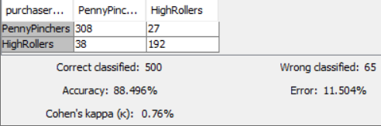

As seen in the screenshot above, the overall accuracy of the model is **88.5%**

* **When the purchaser type is penny pinchers the model classified correctly 308 times and incorrectly 27 times and when it is high rollers the model classified correctly 192 times and incorrectly 38 times.**